Pyber solutions Reports

**PYBER Analysis**

1. There is a correlation between the total number of rides per city and the average fare per city.
2. **Urban cities** in general have lower average fares as seen below. Of total fares highest at 62.72% in the Pie chart below.
3. **Rural cities** had the higher average fare per city the number of drivers are lesser and also the total number of rides are less as compared to Urban cities, the rural cities had the smallest segment of the total fares by city pie chart at 6.81%.
4. Urban cities had the largest percentage of total rides.
5. Urban cities had the largest percentage of drivers and that’s why the average fares are lower due to competition. The Urban cities have more drivers and more riders

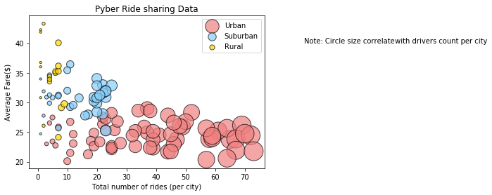

* 1. # % of total fares by City Type

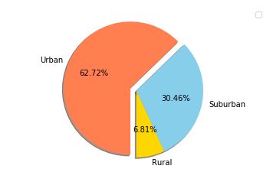

1. #Total rides by city type.

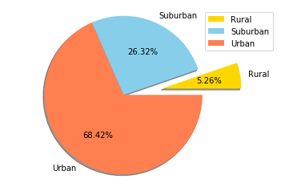

1. #Total drivers by city type.

